Make a Mini-Book like your real book!
Name_____________________________ Date Due: ______________________
Use the following rubric of a book to make a book report of Charlotte’s Web.
Rubric for Mini-Book
Front Cover (should include Title/author/illustrator) 2 pts.
Page 1– Write a paragraph about the main idea of the book. 5 pts.
Page 2- Draw a picture to illustrate the main idea. 2 pts.
Page 3- Write a paragraph about your favorite scene from the book. Remember to tell why it is your favorite part. 5 pts.
Page 4- Draw a picture to illustrate your favorite part. 2 pts.
Pages 5- Write a paragraph about your favorite character, and 5 pts.
how they changed throughout the story.
Page 6- Draw a picture of your favorite character. 2 pts.
Creativity (What did you add to your story to show your creativity… 4 pts.
did you glue on something to make it 3-D, include a map of where your story takes place, or some important prop. You may use some other idea besides the ones mentioned here, but it must show your creative thinking!)

Neatness- You must have neat penmanship. Your pictures should 5 pts.
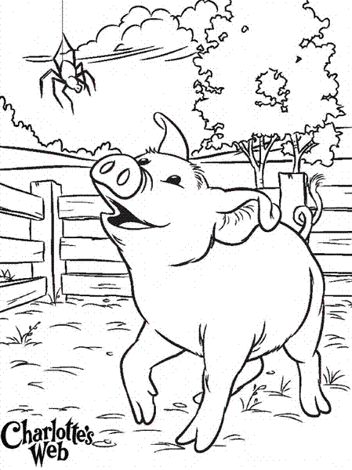
be detailed, and colored neatly.

